How to join Sunday Service via telephone
- Dial the church’s Zoom conference number 647 5580588
- At the prompt, press conference code 811 4193 0530#
- Wait for conference host to admit your call
- Join in the service

SundayServiceZoomlink:
https://us02web.zoom.us/j/81141930530

Every Wednesday from at 7.00p.m..
Prayer Conference line 647 478 7145
Conference code: 133609

PRAYER CONCERNS:
• Pastor Elisabeth and her family for healing and renewal of their
strength for His glory
• Governance Board to be graced with leadership and unity.
• God to lead us to people ready to receive the good news of
Christ.
• God to raise up youth ministers. Praise God for what he plans.
• Our youth and adult bible study group to be effective in
discipleship
• God to raise up workers for the harvest of those needing to know
His love.
• Parents to model a living example of faith and faithfulness
• The church in Canada and worldwide to seek first God’s honor.
• new vital ministry groups to flourish in our church.
• A spirit of humility and faith to fill our hearts with love for all.
• The Seniors in our church to have good health, peace and joy.
• Comfort to Derval & Ernestine Hazel, and family on the passing of
his niece Gillian’s husband, may God grant them peace and
comfort.
• Novie’s brother Andy for his health concern due to the pandemic.
• Praise for Sis. Earlene Mathieson and Bro.William Thompson
Who have been receiving improved health.
• Us to see our places of work, play, study as areas where we serve
Christ by actions and words.
• Praise God for His presence with us in all our trials.
• Those who are religious in a ritual sense but
have no saving faith in Christ.
Sunday, February 28, 2021
Cooksville Creek Public School

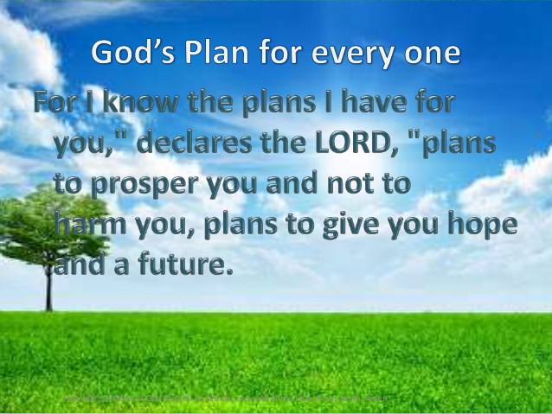
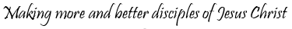

Pastor: Reverend Elisabeth Natividad
Ministers: People of Grace

P.O. Box 13529, Best Buy PO,
3-3221 Derry Rd. W. Mississauga, On. L5N 7L0
ORDER OF SERVICE

OPENING HYMN: In Christ Alone
CONFIRMATION: The Apostles’ Creed

SCRIPTURE READINGS: Deuteronomy 30:15-21
Matthew 7:13-14

PRAYER OF CONFESSION:

PRAISE & WORSHIP: Our God Saves
Lord I Need You
He Will Hold Me Fast

TITHES AND OFFERING:

SERMON: Living as Those Made Alive
in Christ

PASTORAL PRAYER:

CLOSING SONG: Made to Worship

BENEDICTION:
ANNOUNCEMENTS:
AFTER SERVICE FELLOWSHIP: Lets Talk About It

TITLE: Living as Those Made Alive in Christ

------------------------------------------------------------------------------------- -------------------------------------------------------------------------------------- ----------- ---------------------------------------------------------------------------- ---------------------------------------------------------------------------------------- ---------------------------------------------------------------------------------------- ---------------------------------------------------------------------------------------- ---------------------------------------------------------------------------------------- ---------------------------------------------------------------------------------------- ---------------------------------------------------------------------------------------- ---------------------------------------------------------------------------------------- ---------------------------------------------------------------------------------------- ---------------------------------------------------------------------------------------- ---------------------------------------------------------------------------------------- ---------------------------------------------------------------------------------------- ----------------------------------------------------------------------------------------

∙ Holy Communion will take place next Sunday the 7th March. Please remember to prepare the sacraments of wine/grape juice and bread for your family.

∙ Young Adult Group today at 1.00p.m. every Sunday

∙ We are looking for volunteers for the children’s ministry, please let us know if you are interested in serving in this area.

