How to join Sunday Service via telephone
- Dial the church’s Zoom conference number 647 5580588
- At the prompt, press conference code 811 4193 0530#
- Wait for conference host to admit your call
- Join in the service

SundayServiceZoomlink:
https://us02web.zoom.us/j/81141930530

Prayer Meeting every Wednesday from 7.00p.m..
Prayer Conference line 647 478 7145
Conference code: 133609

PRAYER CONCERNS:
• Pastor Elisabeth and her family for healing and renewal of their
strength for His glory
• Governance Board to be graced with leadership and unity.
• God to lead us to people ready to receive the good news of
Christ.
• God to raise up youth ministers. Praise God for what he plans.
• Our youth and adult bible study group to be effective in
discipleship
• God to raise up workers for the harvest of those needing to know
His love.
• Parents to model a living example of faith and faithfulness
• The church in Canada and worldwide to seek first God’s honor.
• new vital ministry groups to flourish in our church.
• A spirit of humility and faith to fill our hearts with love for all.
• The Seniors in our church to have good health, peace and joy.
Who have been receiving improved health.
• Us to see our places of work, play, study as areas where we serve
Christ by actions and words.
• Praise God for His presence with us in all our trials.
• Those who are religious in a ritual sense but
have no saving faith in Christ.
• Pray that God will provide a new home for our church. Also that
He will stir the hearts of more people in our church to serve.

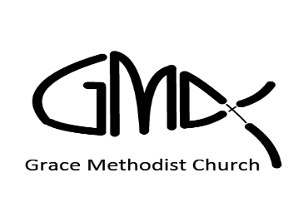
Sunday, October 10th 2021 Cooksville Creek Public School

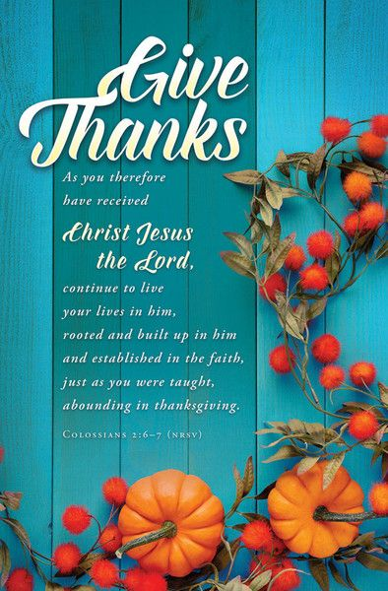

Pastor: Reverend Elisabeth Natividad
Ministers: People of Grace
P.O. Box 13529, Best Buy PO,
3-3221 Derry Rd. W. Mississauga, On. L5N 7L0

ORDER OF SERVICE
SEARCH FOR NEW WORSHIP CENTRE.

New Worship Centre Search Committee. Join us for prayer on Mondays 7.00 – 8.00p.m. Call in via the prayer line.

OPENING HYMN: Lord You Are Good

CONFIRMATION: The Apostles’ Creed

SCRIPTURE READING: Matthew 15: 10 –19 - Kathy

PRAYER OF CONFESSION:

PRAISE & WORSHIP: Open The Eyes of My Heart
Goodness of God
Be Still My Soul

TITHES AND OFFERING:

SERMON : Pastor Elisabeth Natividad
COMMUNION:

PASTORAL PRAYER:

CLOSING/BENEDICTION Thank You Lord
ANNOUNCEMENT:

▪ Worship Team: Kyle, Alex & Monique

▪ Birthdays: Ana Natividad – 11th, Christina Natividad – 12th, Justine Natividad & Lilah Sta Maria – 16th.

▪ Youth Adult Life Group Meetings. – Sundays via Zoom
@ 1.00pm

▪ Youth Bible Study. Mondays via Zoom @ 1.00p.m to 2.30pm

▪ GMC Monthly in-person worship service at Four Points Hotel, 24th October, 10.30am to 12.00pm. RSVP required, only 40 persons are allowed. Covid restrictions such as social distancing, mask indoors and proof of double vaccination required. Live-stream of service via Zoom available as well.

