How to join Sunday Service via telephone
- Dial the church’s Zoom conference number 647 5580588
- At the prompt, press conference code 811 4193 0530#
- Wait for conference host to admit your call
- Join in the service

Sunday Service Zoom link:
https://us02web.zoom.us/j/81141930530

Prayer Meeting every Wednesday from 7.00p.m.
Prayer Conference line 647 478 7145
Conference code: 133609

PRAYER CONCERNS:
• Pastor Elisabeth and her family for healing and renewal of their
strength for His glory
• Governance Board to be graced with leadership and unity.
• God to lead us to people ready to receive the good news of
Christ.
• God to raise up youth ministers. Praise God for what he plans.
• Our youth and adult bible study group to be effective in
discipleship
• God to raise up workers for the harvest of those needing to know
His love.
• William & Willis Thompsons who are experiencing health issues.
• Parents to model a living example of faith and faithfulness
• The church in Canada and worldwide to seek first God’s honor.
• new vital ministry groups to flourish in our church.
• A spirit of humility and faith to fill our hearts with love for all.
• The Seniors in our church to have good health, peace, and joy,
who have been receiving improved health.
• Us to see our places of work, play, study as areas where we serve
Christ by actions and words.
• Praise God for His presence with us in all our trials.
• Those who are religious in a ritual sense but
have no saving faith in Christ.
• Pray that God will provide a new home for our church, and that
He will stir the hearts of more people in our church to serve.

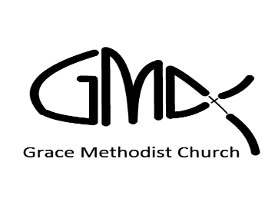

Sunday, Jul 17th, 2022

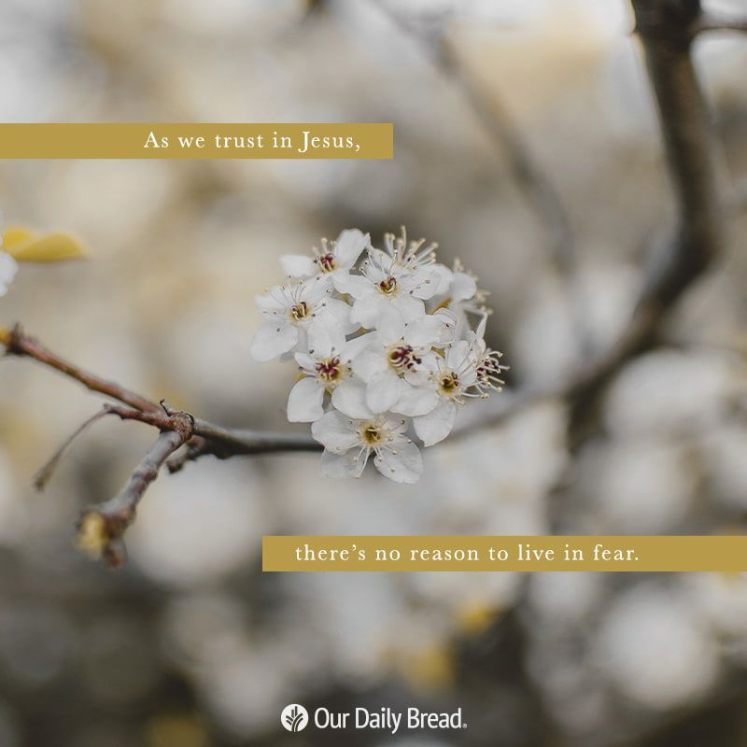
Pastor: Reverend Elisabeth Natividad
Ministers: People of Grace
P.O. Box 13529, Best Buy PO, 3-3221 Derry Rd. W.
Mississauga, On. L5N 7L0

ORDER OF SERVICE

OPENING HYMN: Be Thou My Vision

CONFIRMATION: The Apostles’ Creed

SCRIPTURE READING: 1. Isaiah 41:8-13 (Celia)
2. Titus 2:11-14 (Okibe)

PRAYER OF CONFESSION:

Peace Greeting:

PRAISE & WORSHIP: 1. Hear Our Praises
2. How Deep The Father's Love for Us
3. Be the Centre

Offering/Doxology:

Sermon: Life After coming to Christ is Different than Life Before - Drastically!

Prayer:

Closing Song: Great In Power

Announcements:
- 1. Next in-person worship will be on Jul 24th at Sheridan College, Hazel McCallion Campus, Building A, Level 2. Room A245
- 2. Baptism service on Aug 14. All who wish to be baptised are invited to contact Pastor Elisabeth.
- 3. Wednesday Prayer Meeting at 7pm via GMC Prayer Call Line 647 478 7145 (133609)
Birthdays & Anniversaries:
1. Birthdays : None this week.
2. Next In-person Worship: July 24
3. Weekly Wednesday Prayer Meeting
Small Groups of Grace:

▪ Young Adult Life Group Meetings. – will resume in Sept’22. Any Young Adult interested to join, please contact Kae Natividad.
▪ Youth Bible Study- will resume in Sept’22. Interested youth, please contact Kyle De Kock.
- Weekly Adult Small Groups are on-going. Anyone interested to join a small group bible study, please contact Pastor Elisabeth.

