How to join Sunday Service via telephone
- Dial the church’s Zoom conference number 647 5580588
- At the prompt, press conference code 811 4193 0530#
- Wait for conference host to admit your call
- Join in the service

Sunday Service Zoom link:
https://us02web.zoom.us/j/81141930530

Prayer Meeting every Wednesday from 7.00p.m.
Prayer Conference line 647 478 7145
Conference code: 133609

PRAYER CONCERNS:
• Pastor Elisabeth and her family for healing and renewal of their
strength for His glory
• Governance Board to be graced with leadership and unity.
• God to lead us to people ready to receive the good news of
Christ.
• God to raise up youth ministers. Praise God for what he plans.
• Our youth and adult bible study group to be effective in
discipleship
• God to raise up workers for the harvest of those needing to know
His love.
• Parents to model a living example of faith and faithfulness
• The church in Canada and worldwide to seek first God’s honor.
• new vital ministry groups to flourish in our church.
• A spirit of humility and faith to fill our hearts with love for all.
• The Seniors in our church to have good health, peace, and joy,
who have been receiving improved health.
• Us to see our places of work, play, study as areas where we serve
Christ by actions and words.
• Praise God for His presence with us in all our trials.
• Those who are religious in a ritual sense but
have no saving faith in Christ.
• Pray that God will provide a new home for our church, and that
He will stir the hearts of more people in our church to serve.

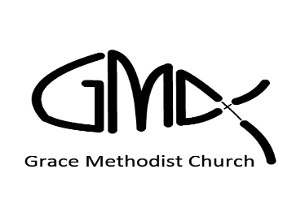

Sunday, August 28th 2022
, 2022

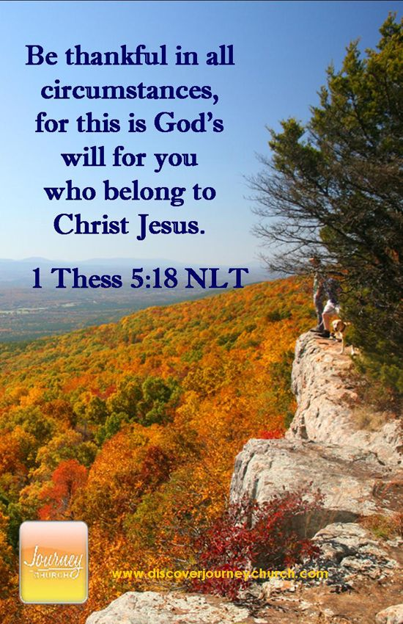
Pastor: Reverend Elisabeth Natividad
Ministers: People of Grace
P.O. Box 13529, Best Buy PO, 3-3221 Derry Rd. W.
ON. L5N 7L0

ORDER OF SERVICE

OPENING HYMN: In Christ Alone

CONFIRMATION: The Apostles’ Creed

SCRIPTURE READING: 1.) Psalm 44: 1 – 8 - Alex
2.) Romans 8: 16 – 25 - Heather

PRAYER OF CONFESSION:
Peace Greeting:

PRAISE & WORSHIP: 1. Hear Our Praises
2. Offering
3. Good and Gracious King

Offering/Doxology:

Sermon: Guest Speaker: Tom Gurnick
”If God is for us, who can be against us?” Romans 8:31
Prayer:

Closing Song: You Cannot Be Stopped

Announcements:
1. Next in-person worship will be on September 04th at Sheridan College, Hazel McCallion Campus, Building A, Level 2. Room A245
2. Wednesday Prayer Meeting at 7pm via GMC Prayer Call Line 647 478 7145 (133609)
3. Change Conf Toronto 2022 - Youth Conference Who: Teens - 12-18 year old When: October 14 & 15, 2022 Where: The Church on the Queensway Contact Kyle for more information
4. Scripture Readers for September 4th: Vanessa and Petal
5. Birthdays: Raquel Teodoro August 28th Joanne Peios September 1st.
Small Groups of Grace:
6▪ Young Adult Life Group Meetings – will resume Sept’22
Any Young Adult interested to join, please contact Kae
Natividad.
▪ Youth Bible Study- will resume in Sept’22. Interested youth
please contact Kyle De Kock.
- Weekly Adult Small Groups are on-going. Anyone interested to join a small group bible study, please contact Pastor Elisabeth.

