How to join Sunday Service via telephone
- Dial the church’s Zoom conference number 647 5580588
- At the prompt, press conference code 811 4193 0530#
- Wait for conference host to admit your call
- Join in the service

SundayServiceZoomlink:
https://us02web.zoom.us/j/81141930530

Every Wednesday from at 7.00p.m..
Prayer Conference line 647 478 7145
Conference code: 133609

PRAYER CONCERNS:
• Pastor Elisabeth and her family for healing and renewal of their
strength for His glory
• Governance Board to be graced with leadership and unity.
• God to lead us to people ready to receive the good news of
Christ.
• God to raise up youth ministers. Praise God for what he plans.
• Our youth and adult bible study group to be effective in
discipleship
• God to raise up workers for the harvest of those needing to know
His love.
• Parents to model a living example of faith and faithfulness
• The church in Canada and worldwide to seek first God’s honor.
• new vital ministry groups to flourish in our church.
• A spirit of humility and faith to fill our hearts with love for all.
• The Seniors in our church to have good health, peace and joy.
• Earlene Mathieson, Willis Thompson, Tanya’s brother and sister,
Bibi’s daughter and grandson for healing of health issues.
• Joanne and Angelina for strength and that God’s will prevails for
Adelina.
• Evelyne’s friend Mertella, for healing.
• Condolence to Bharthi on the passing of Anthony’s uncle, Danny.
• Us to see our places of work, play, study as areas where we serve
Christ by actions and words.
• Praise God for His presence with us in all our trials.
• Those who are religious in a ritual sense but
have no saving faith in Christ.
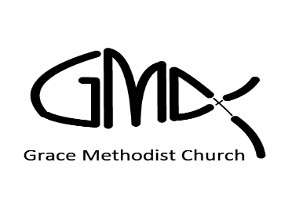
Sunday, January 31st 2021
Cooksville Creek Public School

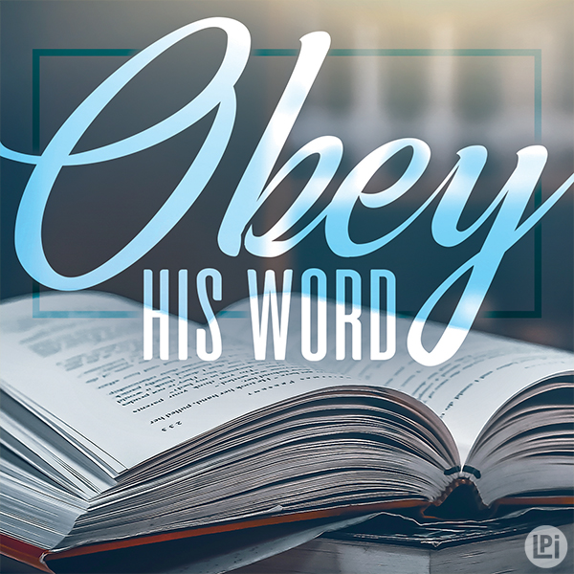

Interim Pastor: Pastor Jim Kesselring 905-509-6534

Ministers: People of Grace
P.O. Box 13529, Best Buy PO,
3-3221 Derry Rd. W. Mississauga, On. L5N 7L0

ORDER OF SERVICE

OPENING HYMN: To God Be The Glory
CONFIRMATION: The A Creed

SCRIPTURE: Prov. 14: 17,29, Prov. 15:1
Prov. 29: 11,22 Matt. 5: 17-26

PRAISE & WORSHIP: Found In You
His Mercy is More
Worthy is the Lamb

TITHES AND OFFERING:

SERMON: Pastor Jim “Sermon on the Mount ”

PASTORAL PRAYER:
CLOSING SONG: Father Let Me Dedicate

BENEDICTION:

ANNOUNCEMENTS:
AFTER SERVICE FELLOWSHIP: Lets Talk About It

THE SERMON ON THE MOUNT
MATTHEW 5: 17-26

TITLE: WE HAVE ALL BROKEN THE SIXTH COMMANDMENT

--------------------------------------------------------------------------------------------------------------------------------------------------------------------------------------------------------------------------------------------------------------------------------------------------------------------------------------------------------------------------------------------------------------------------------------------------------------------------------------------------------------------------------------------------------------------------------------------------------------------------------------------------------------------------------------------------------------------------------------------------------------------------------------------------------------------------------------------------------------------------------------------------------------------------------------------------------------------------------------------------------------------------------------------------------------------------------------------------------------------------------------------------------------------------------------------------------------------------------------------------------------------------------------------------------------------------------------

∙ From February 2021 onwards, Holy Communion will take place on
the first Sunday of each month. Please remember to prepare the
sacraments of wine/grape juice and bread for your family.

∙ We are looking for volunteers for the children’s ministry, please
let us know if you are interested in serving in this area.

