How to join Sunday Service via telephone
- Dial the church’s Zoom conference number 647 5580588
- At the prompt, press conference code 811 4193 0530#
- Wait for conference host to admit your call
- Join in the service

SundayServiceZoomlink:
https://us02web.zoom.us/j/81141930530

Every Wednesday from at 7.00p.m..
Prayer Conference line 647 478 7145
Conference code: 133609

PRAYER CONCERNS:
• Pastor Elisabeth and her family for healing and renewal of their
strength for His glory
• Governance Board to be graced with leadership and unity.
• God to lead us to people ready to receive the good news of
Christ.
• God to raise up youth ministers. Praise God for what he plans.
• Our youth and adult bible study group to be effective in
discipleship
• God to raise up workers for the harvest of those needing to know
His love.
• Parents to model a living example of faith and faithfulness
• The church in Canada and worldwide to seek first God’s honor.
• new vital ministry groups to flourish in our church.
• A spirit of humility and faith to fill our hearts with love for all.
• The Seniors in our church to have good health, peace and joy.
Who have been receiving improved health.
• Us to see our places of work, play, study as areas where we serve
Christ by actions and words.
• Praise God for His presence with us in all our trials.
• Those who are religious in a ritual sense but
have no saving faith in Christ.

Sunday, March 22nd 2021
Cooksville Creek Public School

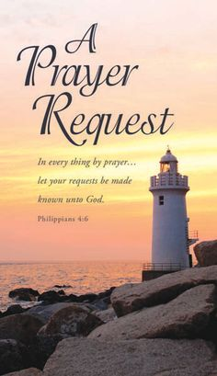
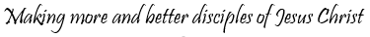

Pastor: Reverend Elisabeth Natividad
Ministers: People of Grace

P.O. Box 13529, Best Buy PO,
3-3221 Derry Rd. W. Mississauga, On. L5N 7L0

ORDER OF SERVICE

OPENING HYMN: To God Be The Glory
CONFIRMATION: The Apostles’ Creed

SCRIPTURE READINGS: Jeremiah 31:31-34-Bharthi Premji
Hebrews 5:5-10- Tina Natividad

PRAYER OF CONFESSION:

PRAISE & WORSHIP: Even so Come
At the Cross (Love Ran Red)
Be Lifted Up

TITHES AND OFFERING:

SERMON:

PASTORAL PRAYER:

CLOSE/BENEDICTION: Because He Lives

AFTER-SERVICE FELLOWSHIP:

SERMON NOTES:

------------------------------------------------------------------------------------- -------------------------------------------------------------------------------------- ----------- ---------------------------------------------------------------------------- ---------------------------------------------------------------------------------------- ---------------------------------------------------------------------------------------- ---------------------------------------------------------------------------------------- ---------------------------------------------------------------------------------------- ---------------------------------------------------------------------------------------- ---------------------------------------------------------------------------------------- ---------------------------------------------------------------------------------------- ---------------------------------------------------------------------------------------- ---------------------------------------------------------------------------------------- ---------------------------------------------------------------------------------------- ---------------------------------------------------------------------------------------- ----------------------------------------------------------------------------------------

▪ Important Dates:
- Birthdays: Virginia Sta Maria – March 25th Josias Natividad – March 25th
▪ Scripture Readings for March 28th: Robertha Grappy Celia Natividad

▪ Youth Bible Study: Mondays 6.45p.m.

▪ Worship Team: Miguel and Kae

