How to join Sunday Service via telephone
- Dial the church’s Zoom conference number 647 5580588
- At the prompt, press conference code 811 4193 0530#
- Wait for conference host to admit your call
- Join in the service

SundayServiceZoomlink:
https://us02web.zoom.us/j/81141930530

Prayer Meeting every Wednesday from 7.00p.m..
Prayer Conference line 647 478 7145
Conference code: 133609

PRAYER CONCERNS:
• Pastor Elisabeth and her family for healing and renewal of their
strength for His glory
• Governance Board to be graced with leadership and unity.
• God to lead us to people ready to receive the good news of
Christ.
• God to raise up youth ministers. Praise God for what he plans.
• Our youth and adult bible study group to be effective in
discipleship
• God to raise up workers for the harvest of those needing to know
His love.
• Parents to model a living example of faith and faithfulness
• The church in Canada and worldwide to seek first God’s honor.
• new vital ministry groups to flourish in our church.
• A spirit of humility and faith to fill our hearts with love for all.
• The Seniors in our church to have good health, peace and joy.
Who have been receiving improved health.
• Us to see our places of work, play, study as areas where we serve
Christ by actions and words.
• Praise God for His presence with us in all our trials.
• Those who are religious in a ritual sense but
have no saving faith in Christ.
• Pray that God will provide a new home for our church. Also that
He will stir the hearts of more people in our church to serve.

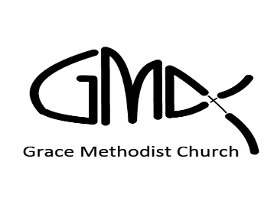
Sunday, August 22nd 2021
Cooksville Creek Public School

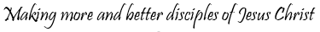

Pastor: Reverend Elisabeth Natividad
Ministers: People of Grace
P.O. Box 13529, Best Buy PO,
3-3221 Derry Rd. W. Mississauga, On. L5N 7L0

ORDER OF SERVICE

OPENING HYMN: Be Unto His Name

CONFIRMATION: The Apostles’ Creed

SCRIPTURE READINGS: Genesis 15:1-6 – Myra
John 3: 16-18 - Petal

PRAYER OF CONFESSION:

PRAISE & WORSHIP: This I Believe ( The Creed)
Yet Not I But Through Christ in Me
From the Inside Out

TITHES AND OFFERING:

SERMON :

PASTORAL PRAYER:

CLOSING/BENEDICTION God is Able

AFTER-SERVICE FELLOWSHIP: Iron Sharpens Iron

SEARCH FOR NEW WORSHIP CENTER.

New Worship Center Search Committee. Join us for prayer on Mondays 7.00 – 8.00p.m. Call in via the prayer line.

▪ Worship Team: Kyle, Alex & Monique

▪ Birthdays: Cynthia Maynard – 25th
Raquel Teodoro – 28th

▪ Young Adult Group starts on 29th August
on zoom at 1.00p.m. contact Monique to join at
moniqueschai@gmail.com

▪ Youth Group. Contact Kyle to join

▪ GMC Summer Worship & Fellowship @ JC Saddington
Park on 12th September from 10.30 am to 1.00p.m.

