How to join Sunday Service via telephone
- Dial the church’s Zoom conference number 647 5580588
- At the prompt, press conference code 811 4193 0530#
- Wait for conference host to admit your call
- Join in the service

SundayServiceZoomlink:
https://us02web.zoom.us/j/81141930530

Prayer Meeting every Wednesday from 7.00p.m..
Prayer Conference line 647 478 7145
Conference code: 133609

PRAYER CONCERNS:
• Pastor Elisabeth and her family for healing and renewal of their
strength for His glory
• Governance Board to be graced with leadership and unity.
• God to lead us to people ready to receive the good news of
Christ.
• God to raise up youth ministers. Praise God for what he plans.
• Our youth and adult bible study group to be effective in
discipleship
• God to raise up workers for the harvest of those needing to know
His love.
• William & Willis Thompsons who are experiencing health issues.
• Parents to model a living example of faith and faithfulness
• The church in Canada and worldwide to seek first God’s honor.
• new vital ministry groups to flourish in our church.
• A spirit of humility and faith to fill our hearts with love for all.
• The Seniors in our church to have good health, peace and joy.
Who have been receiving improved health.
• Us to see our places of work, play, study as areas where we serve
Christ by actions and words.
• Praise God for His presence with us in all our trials.
• Those who are religious in a ritual sense but
have no saving faith in Christ.
• Pray that God will provide a new home for our church. Also that
He will stir the hearts of more people in our church to serve.

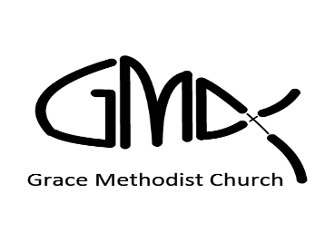
Sunday, January 09th 2022
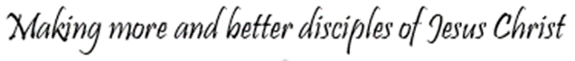

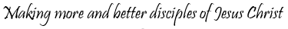
Pastor: Reverend Elisabeth Natividad
Ministers: People of Grace
P.O. Box 13529, Best Buy PO, 3-3221 Derry Rd. W.
Mississauga, On. L5N 7L0
ORDER OF SERVICE

OPENING HYMN: Great is Thy Faithfulness

CONFIRMATION: The Apostles’ Creed

SCRIPTURE READING: Psalm 1
1 Peter 4:12-19
Sudhakar

PRAYER OF CONFESSION:

PRAISE & WORSHIP: Lord I Lift Your Name On High
Because He Lives
Be Glorified In Me (Father Let Me Dedicate)

Offering/Doxology:

Sermon Reverend Elisabeth Natividad

Prayer

Closing Song: Salvation Belongs To Our God

Announcements:

Birthdays: Al Fernandez (Jan 10)

. No In-Person Worship on Jan 16th due to latest Covid Restrictions applicable to hotel sector.
▪ Youth Adult Life Group Meetings. – Resumes on Sunday Jan 9th 1pm on Zoom.
▪ Youth Bible Study- Resumes on Monday Jan 10th at 6:45pm on Zoom.

. New Worship Committee Prayer meeting- Resumes Jan 10th, every Monday, 6:45 via conference Call. All are welcome.

. Wednesday Prayer Meeting at 7:00pm.

