How to join Sunday Service via telephone
- Dial the church’s Zoom conference number 647 5580588
- At the prompt, press conference code 811 4193 0530#
- Wait for conference host to admit your call
- Join in the service

SundayServiceZoomlink:
https://us02web.zoom.us/j/81141930530

Prayer Meeting every Wednesday from 7.00p.m.
Prayer Conference line 647 478 7145
Conference code: 133609

PRAYER CONCERNS:
• Pastor Elisabeth and her family for healing and renewal of their
strength for His glory
• Governance Board to be graced with leadership and unity.
• God to lead us to people ready to receive the good news of
Christ.
• God to raise up youth ministers. Praise God for what he plans.
• Our youth and adult bible study group to be effective in
discipleship
• God to raise up workers for the harvest of those needing to know
His love.
• William & Willis Thompsons who are experiencing health issues.
• Parents to model a living example of faith and faithfulness
• The church in Canada and worldwide to seek first God’s honor.
• new vital ministry groups to flourish in our church.
• A spirit of humility and faith to fill our hearts with love for all.
• The Seniors in our church to have good health, peace and joy,
who have been receiving improved health.
• Us to see our places of work, play, study as areas where we serve
Christ by actions and words.
• Praise God for His presence with us in all our trials.
• Those who are religious in a ritual sense but
have no saving faith in Christ.
• Pray that God will provide a new home for our church, and that
He will stir the hearts of more people in our church to serve.

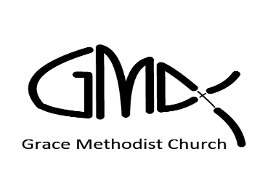

Sunday, March 13th, 2022

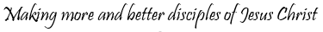
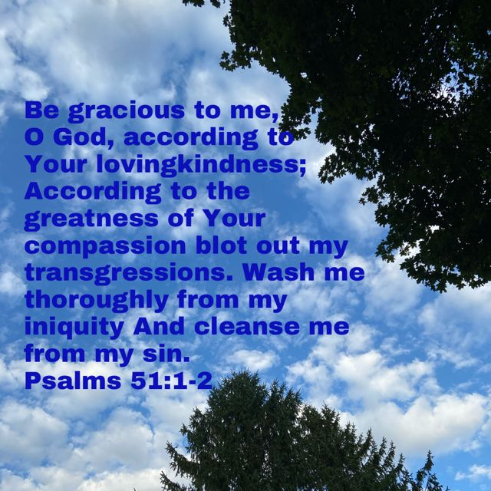
Pastor: Reverend Elisabeth Natividad
Ministers: People of Grace
P.O. Box 13529, Best Buy PO, 3-3221 Derry Rd. W.
Mississauga, On. L5N 7L0

ORDER OF SERVICE

OPENING HYMN: The Wonderful Cross
CONFIRMATION: The Apostles’ Creed

SCRIPTURE READING: Psalms 51:1-8 (Dawn)
2 Corinthians 5:11-6:2 (Evelyne)

PRAYER OF CONFESSION:

PRAISE & WORSHIP: This Is Amazing Grace
It Is Well (Traditional)
Reign In Us
Offering/Doxology:

Sermon Reverend Jim Kesselring

Prayer

Closing Song: My Life Is In You

Announcements: a) In-person Worship at the Four Points Hotel by the Sheraton at Argentia Road on March 20, 10.30am. Come worship together.
b) Tuesday Evening Bible Study of Ruth and Esther with Pastor Jim Kesselring from March 15 to April 5. Contact Pastor Jim at kesselringjc@gmail.com for more information.
c) Youth Group outing on March 26. For more information, contact Kyle at dekock.kyle@gmail.com

Birthdays: Birthdays & Anniversaries
Bercy Palor (Mar. 13)
▪ Youth Adult Life Group Meetings. – Sunday Mar 13th 1pm on Zoom.
▪ Youth Bible Study- Monday Mar 14th at 6:45pm on Zoom.

. New Worship Committee Prayer meeting- Every Monday, 6:45 via conference Call. All are welcome.

. Wednesday Prayer Meeting at 7:00pm.

