How to join Sunday Service via telephone
- Dial the church’s Zoom conference number 647 5580588
- At the prompt, press conference code 811 4193 0530#
- Wait for conference host to admit your call
- Join in the service

SundayServiceZoomlink:
https://us02web.zoom.us/j/81141930530

Prayer Meeting every Wednesday from 7.00p.m.
Prayer Conference line 647 478 7145
Conference code: 133609

PRAYER CONCERNS:
• Pastor Elisabeth and her family for healing and renewal of their
strength for His glory
• Governance Board to be graced with leadership and unity.
• God to lead us to people ready to receive the good news of
Christ.
• God to raise up youth ministers. Praise God for what he plans.
• Our youth and adult bible study group to be effective in
discipleship
• God to raise up workers for the harvest of those needing to know
His love.
• William & Willis Thompsons who are experiencing health issues.
• Parents to model a living example of faith and faithfulness
• The church in Canada and worldwide to seek first God’s honor.
• new vital ministry groups to flourish in our church.
• A spirit of humility and faith to fill our hearts with love for all.
• The Seniors in our church to have good health, peace and joy,
who have been receiving improved health.
• Us to see our places of work, play, study as areas where we serve
Christ by actions and words.
• Praise God for His presence with us in all our trials.
• Those who are religious in a ritual sense but
have no saving faith in Christ.
• Pray that God will provide a new home for our church, and that
He will stir the hearts of more people in our church to serve.

Sunday, May 22th, 2022

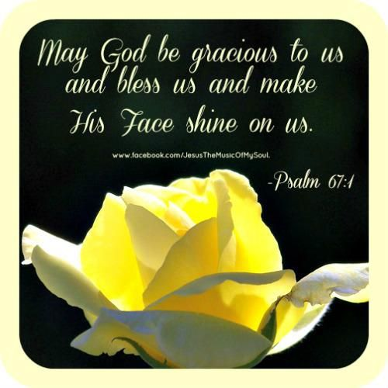
Pastor: Reverend Elisabeth Natividad
Ministers: People of Grace
P.O. Box 13529, Best Buy PO, 3-3221 Derry Rd. W.
Mississauga, On. L5N 7L0
ORDER OF SERVICE

OPENING HYMN: Blessed Assurance

CONFIRMATION: The Apostles’ Creed

SCRIPTURE READING: Psalms 67:1-7 (Myra)
John 14:23-29 (Okibe)
PRAYER OF CONFESSION:

PRAISE & WORSHIP: Wonderful Merciful Saviour
The Cross Has The Final Word
It Is Well
Offering/Doxology:

Sermon: Rev. Elisabeth Natividad

Prayer:

Closing Song: Christ Is Risen

Announcements: 1. May 29 In-Person Worship at Sheridan College
Place: Sheridan College Hazel McCallion Campus, Building A, Level 2, Room A229
Time: 10.30am
Address: 4180 Duke of York Boulevard, Mississauga (Next to Square One)
Parking: Square One P6 (Free), South Municipal Lot (CAD1 per hour)

2. GMC Society Meeting - Our annual meeting will take place on May 29 immediately after the in-person service. Everyone is invited to attend. An agenda will be announced soon.

3. Scripture readers for May 29
Willem and Heather
- Small Groups continue to meet together. Interested in joining one? Contact Pastor Elisabeth.
- Wednesday Prayer Meeting at 7pm via GMC Prayer Call Line 647 478 7145 (133609)
Birthdays & Anniversaries:

1. Jocel Natividad (May 24)

- ▪ Youth Adult Life Group Meetings. – Sunday May 15th 1pm on Zoom.
▪ Youth Bible Study- Monday May 16th at 6:45pm on Zoom.

. New Worship Committee Prayer meeting- Every Monday, 6:45 via conference Call. All are welcome.

. Wednesday Prayer Meeting at 7:00pm.

*Pray For:
1. the Church leadership and members (everyone who considers GMC their home) to be united in the Spirit and open to however God would lead.
2. our children and youth who live in an increasingly complicated and difficult culture to experience God's favor, presence and help.
3. each of us to live more consistently as Christ followers and to recognize the false assumptions held by our culture.
4. each of us to love God more and hate the things that hinder the Spirit's work in our lives.
5. God to raise up workers for His glory.
6. Grace Methodist Church to be a praying and soul winning church.
7. God's protection over marriages.

