How to join Sunday Service via telephone
- Dial the church’s Zoom conference number 647 5580588
- At the prompt, press conference code 811 4193 0530#
- Wait for conference host to admit your call
- Join in the service

SundayServiceZoomlink:
https://us02web.zoom.us/j/81141930530

Prayer Meeting every Wednesday from 7.00p.m.
Prayer Conference line 647 478 7145
Conference code: 133609

PRAYER CONCERNS:
• Pastor Elisabeth and her family for healing and renewal of their
strength for His glory
• Governance Board to be graced with leadership and unity.
• God to lead us to people ready to receive the good news of
Christ.
• God to raise up youth ministers. Praise God for what he plans.
• Our youth and adult bible study group to be effective in
discipleship
• God to raise up workers for the harvest of those needing to know
His love.
• William & Willis Thompsons who are experiencing health issues.
• Parents to model a living example of faith and faithfulness
• The church in Canada and worldwide to seek first God’s honor.
• new vital ministry groups to flourish in our church.
• A spirit of humility and faith to fill our hearts with love for all.
• The Seniors in our church to have good health, peace and joy,
who have been receiving improved health.
• Us to see our places of work, play, study as areas where we serve
Christ by actions and words.
• Praise God for His presence with us in all our trials.
• Those who are religious in a ritual sense but
have no saving faith in Christ.
• Pray that God will provide a new home for our church, and that
He will stir the hearts of more people in our church to serve.

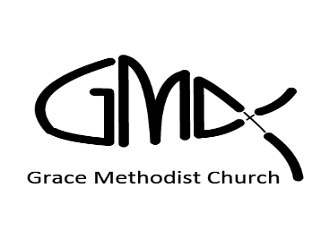

Sunday, Jun 5th, 2022

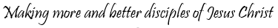
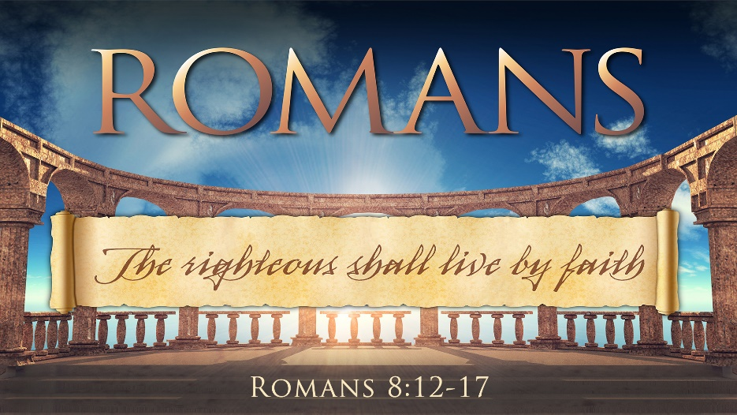
Pastor: Reverend Elisabeth Natividad
Ministers: People of Grace
P.O. Box 13529, Best Buy PO, 3-3221 Derry Rd. W.
Mississauga, On. L5N 7L0

ORDER OF SERVICE

OPENING HYMN: A Mighty Fortress Is Our God

CONFIRMATION: The Apostles’ Creed

SCRIPTURE READING: Genesis 11:1-9 (Vanessa)
Romans 8:12-17 (Petal)

PRAYER OF CONFESSION:

PRAISE & WORSHIP: Kings of Kings
Surrender
Holy Spirit Rain Down

Offering/Doxology:

Sermon: Rev. Elisabeth Natividad
Pentecost: A Reversal of Babel

Holy Communion:

Prayer:

Closing Song: Made To Worship

Announcements: 1. GMC Annual Society Meeting - June 12th immediately after In-Person worship. Everyone's welcome.
- Next in-person worship will be on June 12th at Sheridan College, Hazel McCallion Campus, Building A, Level 2 . Room A245
- Small Groups continue to meet together. Interested in joining one? Contact Pastor Elisabeth.
- Wednesday Prayer Meeting at 7pm via GMC Prayer Call Line 647 478 7145 (133609)
Birthdays & Anniversaries:

  - Monique Spanjaard-Chai (Jun 6)
  - Adelina Peios (Jun 10)

▪ Youth Adult Life Group Meetings. – Sunday Jun 5/22 3pm on Zoom.
▪ Youth Bible Study- Wed Jun 8th
at 6:45pm on Zoom.
. Wednesday Prayer Meeting, 7pm, on GMC Conference Call line 647 4787145 (Conference Code 133609)

