How to join Sunday Service via telephone
- Dial the church’s Zoom conference number 647 5580588
- At the prompt, press conference code 811 4193 0530#
- Wait for conference host to admit your call
- Join in the service

Sunday Service Zoom link:
https://us02web.zoom.us/j/81141930530

Prayer Meeting every Wednesday from 7.00p.m.
Prayer Conference line 647 478 7145
Conference code: 133609

PRAYER CONCERNS:
• Pastor Elisabeth and her family for healing and renewal of their
strength for His glory
• Governance Board to be graced with leadership and unity.
• God to lead us to people ready to receive the good news of
Christ.
• God to raise up youth ministers. Praise God for what he plans.
• Our youth and adult bible study group to be effective in
discipleship
• God to raise up workers for the harvest of those needing to know
His love.
• Parents to model a living example of faith and faithfulness
• The church in Canada and worldwide to seek first God’s honor.
• new vital ministry groups to flourish in our church.
• A spirit of humility and faith to fill our hearts with love for all.
• The Seniors in our church to have good health, peace, and joy,
who have been receiving improved health.
• Us to see our places of work, play, study as areas where we serve
Christ by actions and words.
• Praise God for His presence with us in all our trials.
• Those who are religious in a ritual sense but
have no saving faith in Christ.
• Pray that God will provide a new home for our church, and that
He will stir the hearts of more people in our church to serve.

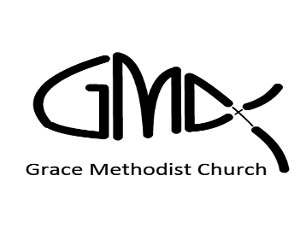

Sunday, October 09, 2022
, 2022

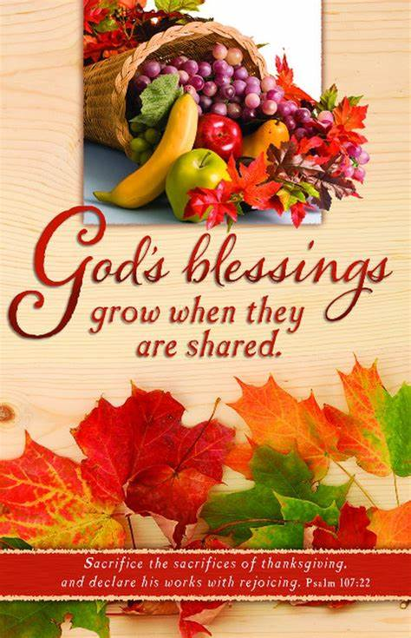
Pastor: Reverend Elisabeth Natividad
Ministers: People of Grace
P.O. Box 13529, Best Buy PO, 3-3221 Derry Rd. W.
ON. L5N 7L0
ORDER OF SERVICE

OPENING HYMN: May All the Peoples Praise You

CONFIRMATION: The Apostles’ Creed

SCRIPTURE READING: 1 Samuel 2: 1-10 – Tanya

PRAYER OF CONFESSION:
Peace Greeting:
PRAISE & WORSHIP: 1. Thank You Lord
2. As The Deer
3. Faithful One
Offering/Doxology:

Sermon:

Prayer:
Closing Song: Tis So Sweet to Trust in Jesus
Benediction:

ANNOUNCEMENTS:
1. Next in-person worship will be on October 16th at Sheridan College, Hazel McCallion Campus, Building A, Level 2. Room A245
2. Wednesday Prayer Meeting at 7pm via GMC Prayer Call Line 647 478 7145 (133609)
3. Youth Conference – 14th – 16th October. There is still time to sign-up, please contact Kyle.
4. Youth Conference volunteers needed! Contact Kyle for more details

5. Birthday Greetings: Ana Natividad – October 11th
Cristina Natividad – October 12th

